Dustin Kendall

kendalld@pnw.edu

Lab 2   
Adder, Comparator, Multiplier, and Rotator

Instructor: Quamar Niyaz

# Schematics









## Part 1 Adder

I used the full adders to implement the 4-bit adders, and then used the 4-bit adders to make the 16-bit adders.

### Functional Simulation Part 1

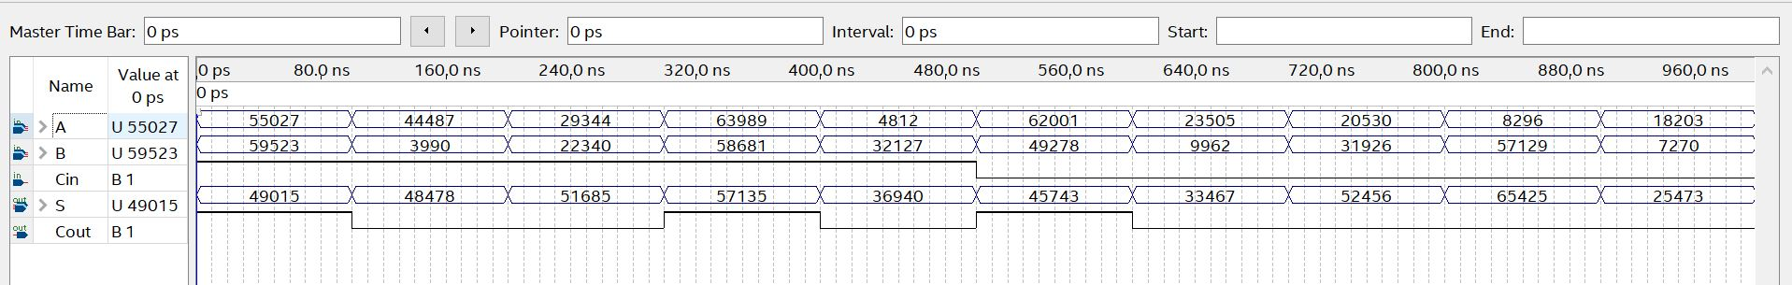

### Synthesized Adder

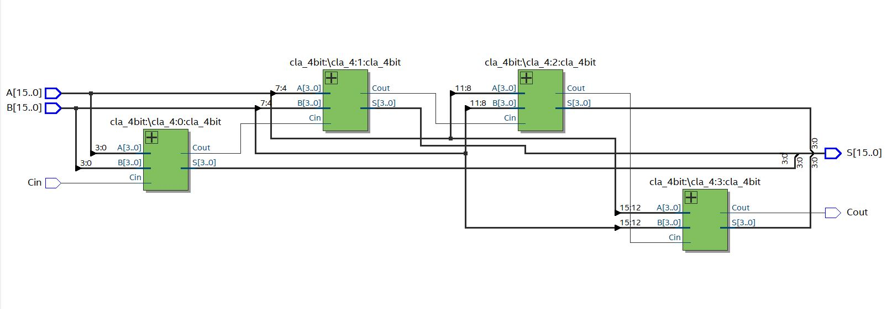

### Files



## Part 2 8 Bit Comparator

### Functional Simulation Part 2

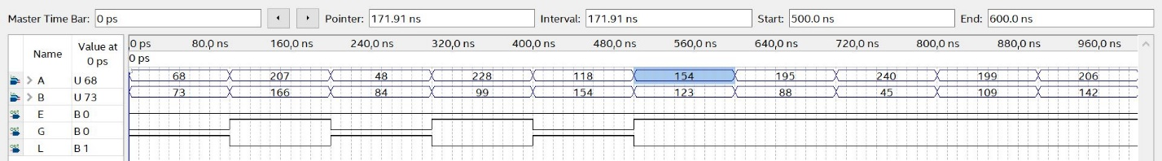

### Synthesized Comparator

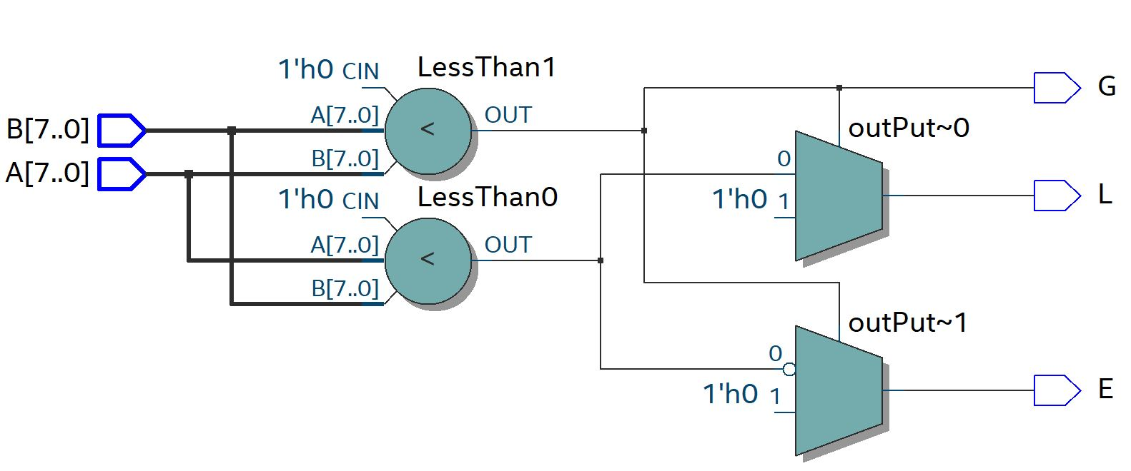

### Files



## Part 3 Multiplier

I used arrays of standard logic vectors to compute the intermediate products, then 4 bit adders from task 1 to compute the sum of the intermediate products.

### Functional Simulation Part 3

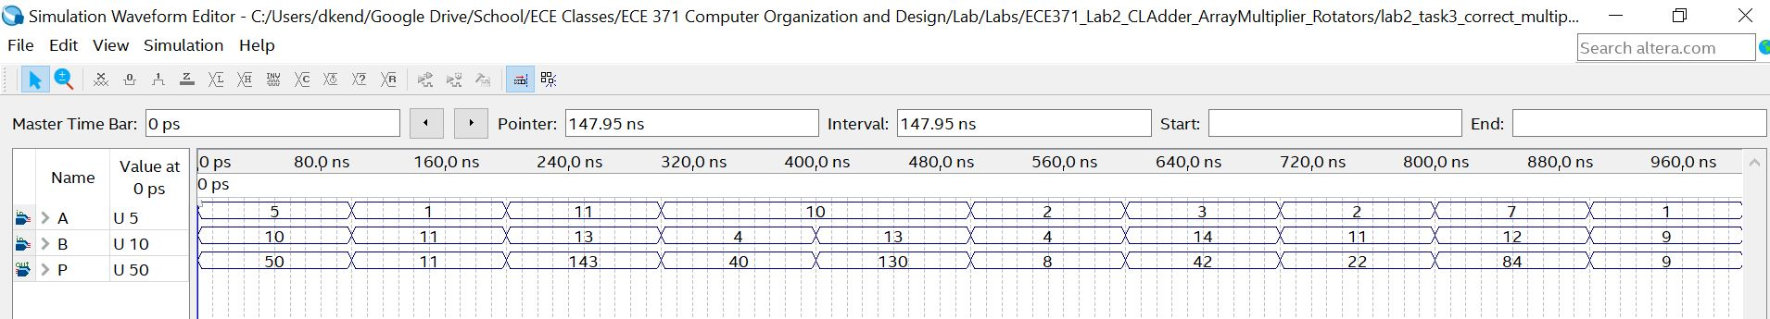

## Multiplier Schematic

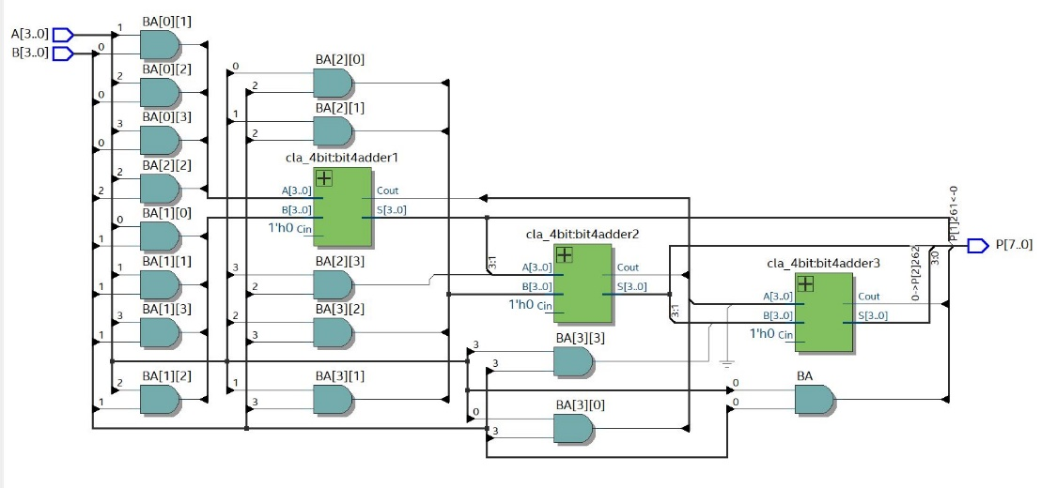

### Files



## Part 4 Rotator

I used one file, which used a line to select whether to shift left or right. When r=1 then you are shifting right, but when r=0, you are shifting left.

### Function Simulation

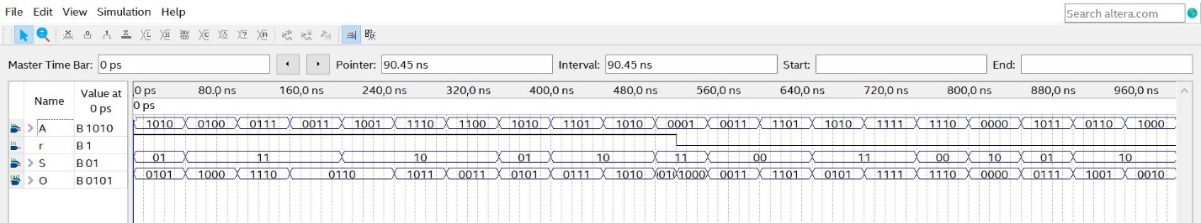

### Synthesized Circuit

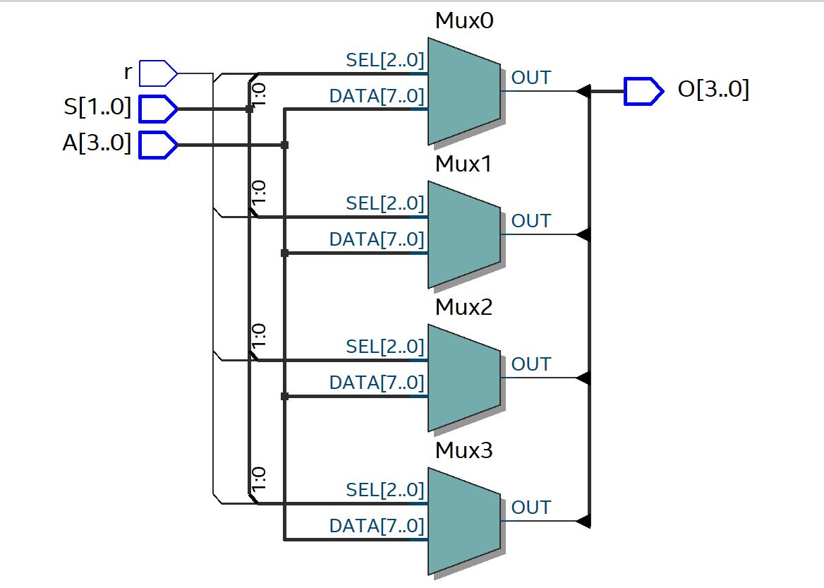

### Files

